1. blocked users/ attacker
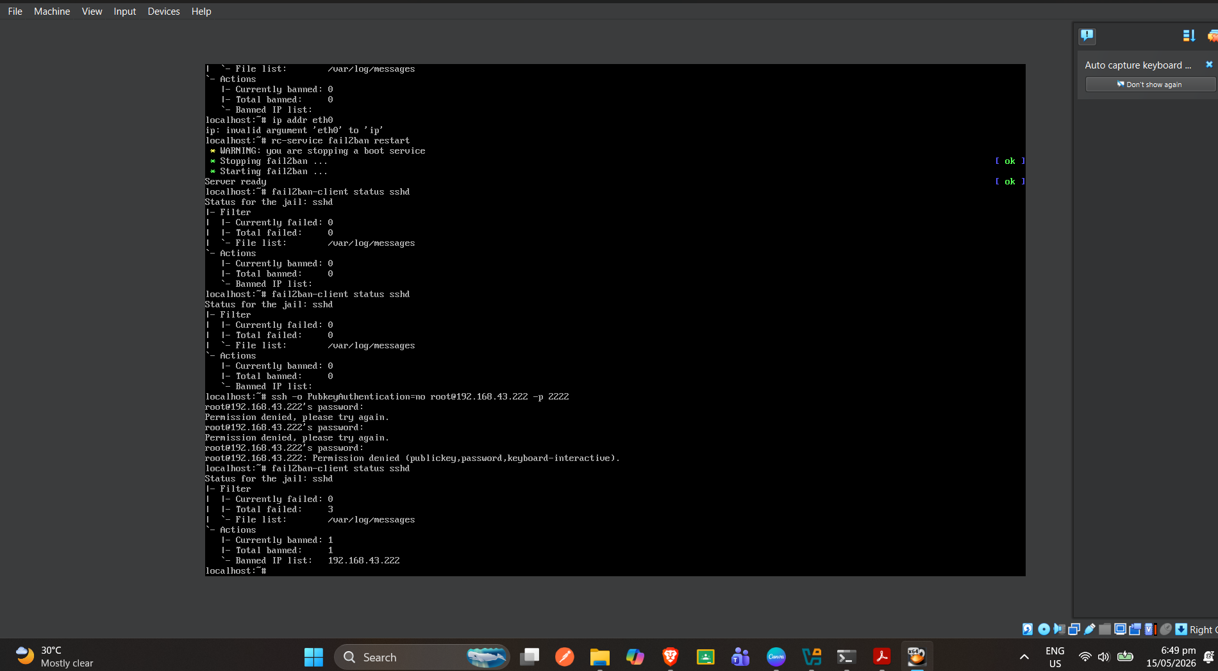

2. mobile hotspot port -2222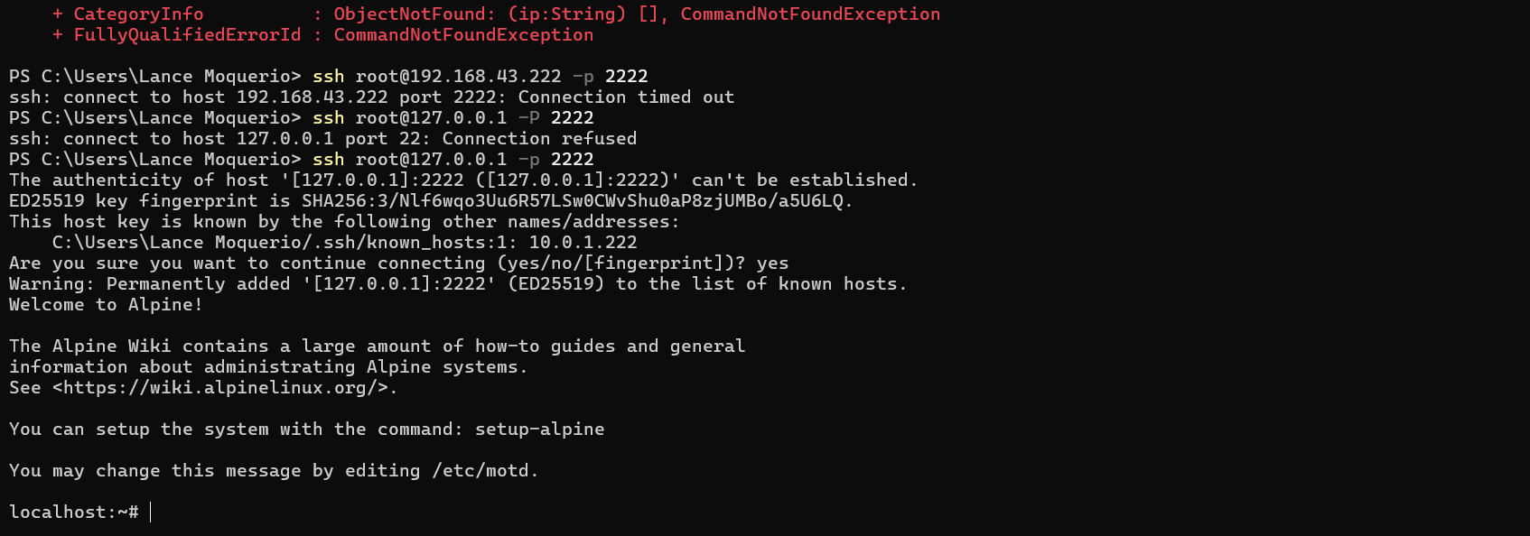

QUESTIONS:
1.
The Gateway was able to establish a direct connection to the Client without altering router settings by utilizing a technique known as UDP/TCP hole punching. Because both devices initiated an outbound connection to a public coordination or STUN server, their respective routers opened dynamic translation ports in their Network Address Translation (NAT) tables. The coordination server shared these temporary, open port mappings between the two devices, allowing them to send traffic directly to each other's public endpoints. The routers accepted this incoming traffic because it matched the existing outbound session states already recorded in their connection tables.

2.
Using an overlay network is significantly more secure than opening Port 22 because it completely hides the server from the public internet. Opening Port 22 on a public router exposes the SSH service to global IP scanners, malicious bots, and constant automated brute-force attacks. In contrast, an overlay network creates an isolated, encrypted virtual network where the server does not listen on a public IP address. To even attempt a connection, a client must first authenticate with the overlay network provider and possess valid cryptographic keys, ensuring only pre-authorized devices can see or interact with the SSH port.

3.
When switching from the local lab network to the mobile hotspot, network latency generally increased and became more variable due to the nature of cellular data propagation and wireless interference. While a local lab network relies on low-latency ethernet or dedicated high-speed enterprise Wi-Fi routers, a mobile hotspot relies on cellular tower triangulation, which introduces higher ping times and occasional jitter. Despite this increase in latency, the underlying VPN tunnel remained stable because modern overlay protocols are designed to handle fluctuating cellular connections, automatically roaming and maintaining the secure state without dropping the session.

